Oliver Proj Analysis

- DESCRIPTIVE STATISTICS

- Categorical Variables

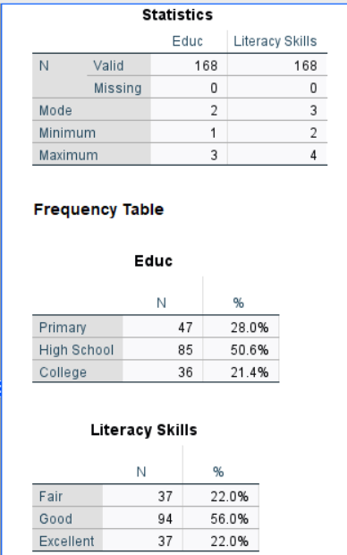

REPORTING
The sample of male respondents consisted of 168 as shown in table x

Table x

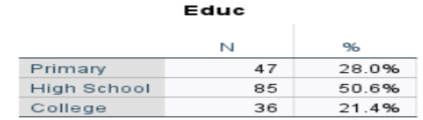

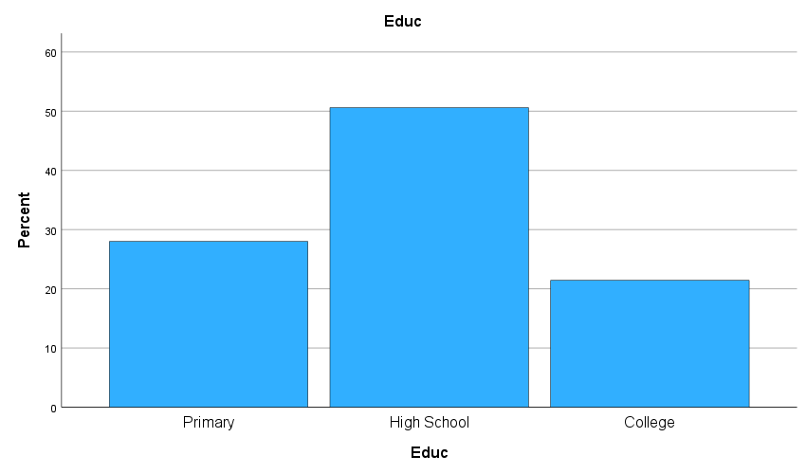

Literacy Skills
The sample of male respondents consisted of 168 as shown in table x

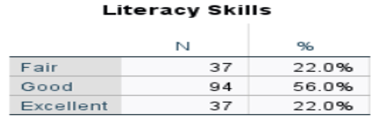

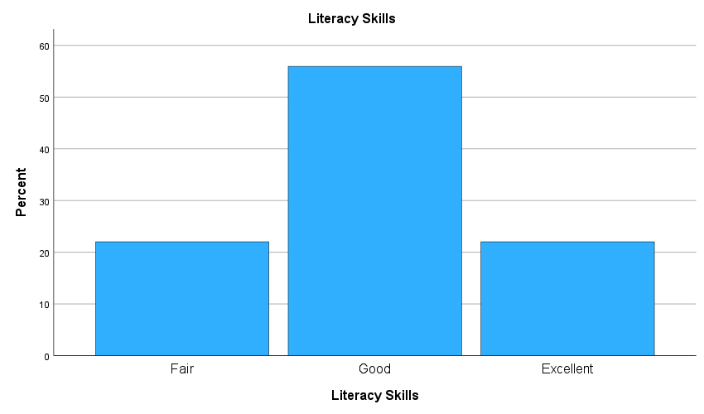

- Nominal Variables

- Continuous Variables
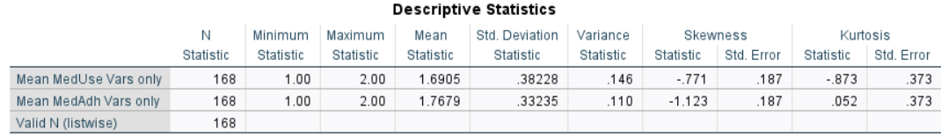
Reporting

Mean Medication Use (MedUse):
The average medUse of male participants was1.6905 (SD=0.38228).

Mean Medication Adherence (MedAdh):
The average medAdh of male participants was1.7679 (SD=0.33235).

- All SocioEconomic Variables within the Model
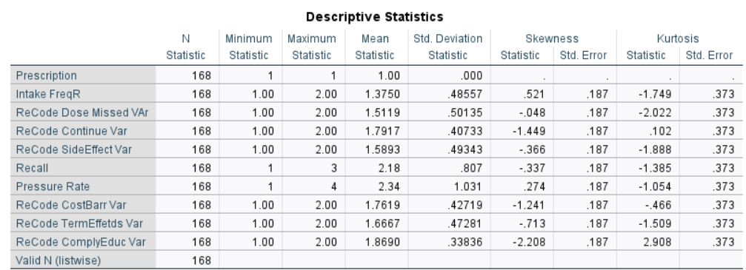
Reporting
This analysis used variables both from the medication use and the medication adherence measures (which collectively form the compliance mediation). The overall mean score for the MedUse variables was ?? (SD=??). The overall mean score for the MedAdj vairables was ?? (SD=??). The overall mean score for the measure (all variables) was xxx (SD=xxx). Pressure Rate, the variable measuring the blood pressure was the highest (2.34) while the lowest mean variable was Intake FreqR, the measurement of the intake frequency was 1.3750 (since all persons were on prescription).
- Descriptive Statistics of Combined Variables: Literacy Skills with SE
.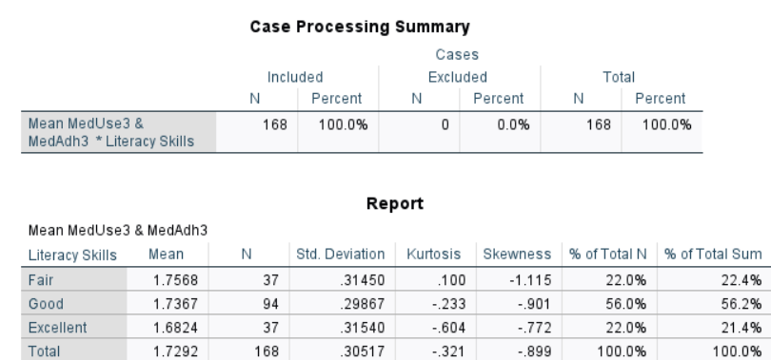

Reporting
Data was collected from males with three different literacy skillsets broken down as fair (n=37), Good (n=94) and Excellent (37). The descriptive statistics show that the mean score on their responses to the compliance medication was Fair (1.7568, SD=0.31450), Good (1.7367, SD=0.29867) and Excellent (1.6824, SD=0.31540).
We note that responses in the Good category were more consistent and had the highest percentage of responses. Kurtosis and Skewness
- Descriptive Statistics of Age with SE
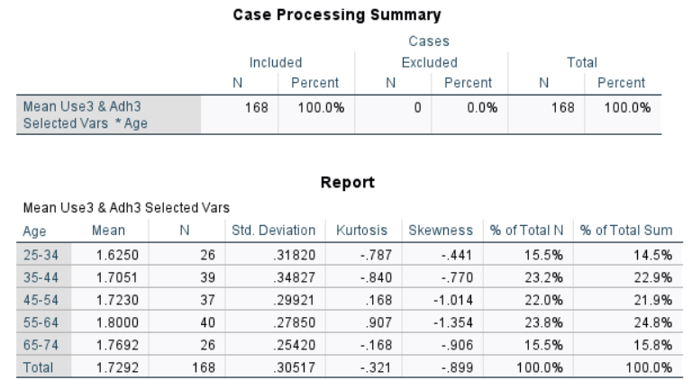
Reporting
Data was collected from males with five three different age groups as 25-34 (n=26), 35-44 (n=39), 45-54 (n=37), 55-64 (n=40) and 65-74 (n=26). The descriptive statistics show that the mean score on their responses to the compliance of medication was 25-34 (1.6250, SD=0.31820, 35-44 (1.7051, SD=.34827), 45-54 (1.7230, SD=.29921), 55-64 (1.8000, SD=.27850) and 65-74 (1.7292, SD=.30517).
We note that the distribution appears normal in terns of the number of respondents surveyed. Responses in the 65-74 group were more consistent in their responses with a smaller SD. The greatest responses came from the 55-64 group (24%). Kurtosis and Skewness

- Crosstabs Descriptives
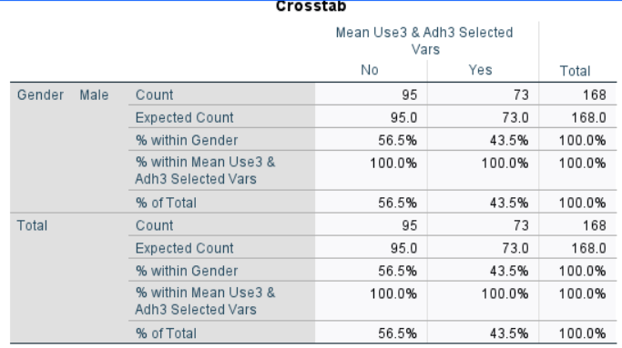

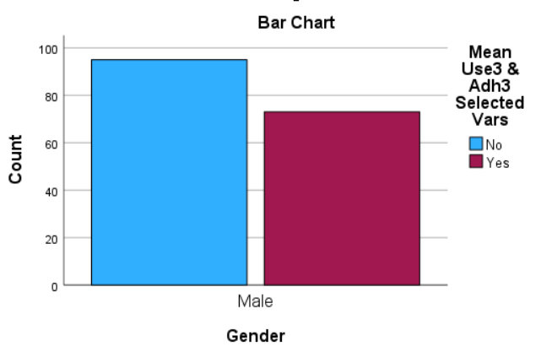

Reportiung
The Problem:
To identify the association between males of difference employment status (yes/no) and their age groups.
Chi-square statistics were used to examine association between age groups of males and their employment status (yes/no). The simple table displays the frequency counts and their corresponding percentages.

- RELIABILITY ANALYSIS
Research with Fawad - https://www.youtube.com/watch?v=aZMvuTc1HuM&list=UULFj4wQNQTmRPbOd1rcAOkU6Q&index=88
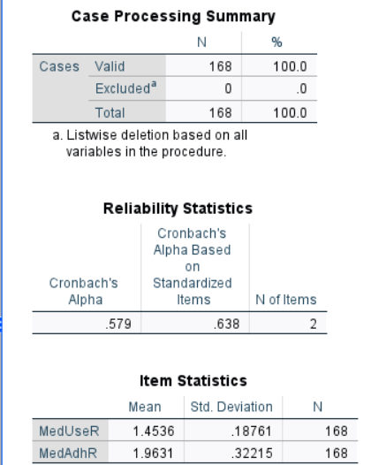

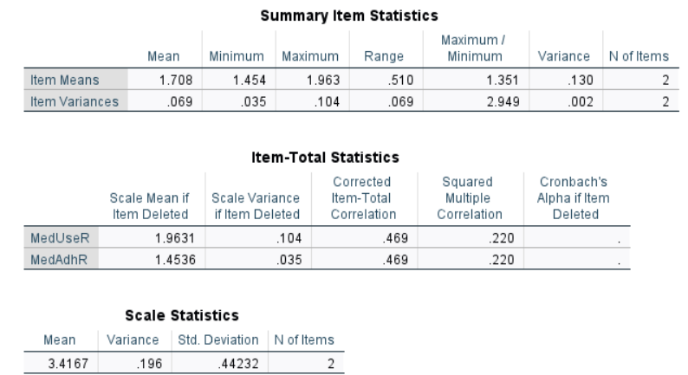

- Variables had to be recoded so that the entire dataset was staged in the same direction; that is the lowest value in each response was given 1 so that the Reliability Measure could have acceptable values across the dataset. In all cases, 1 signifies the lowest response.
- Combined reliable measure for the Medication User and Medication Adherence variables was 0.579 (Reliability Statistics table – above) but performing an analysis on the variables separately, we see that the reliability measure is quite low, 0.219 (Reliability Statistics table - below).
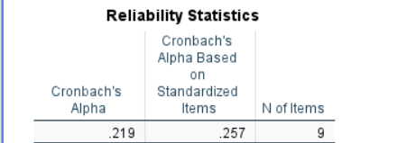

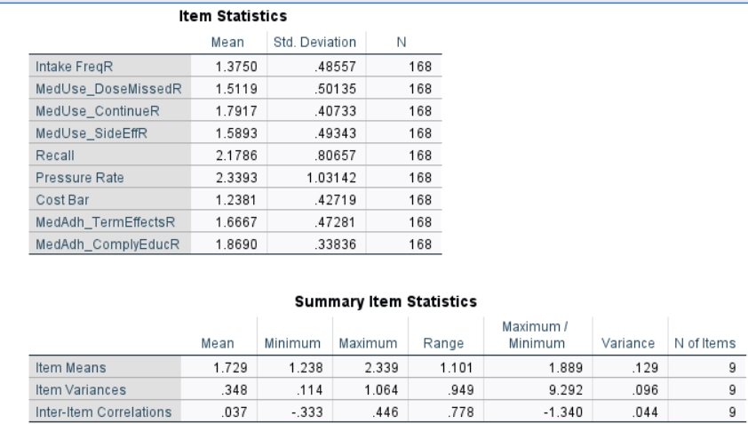

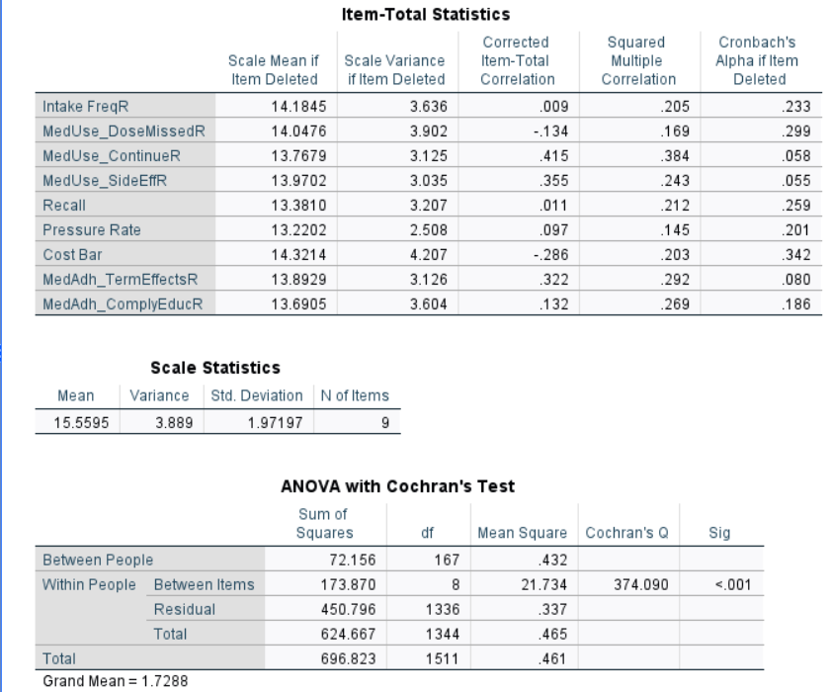

- From the Item-Total Statistics, we note that the removal of the MedUse_DoseMissedR variable would produce a reliability value of 0.299.
- Consecutive removal of variables: CostBarr, BloodPress, InTake saw the rise of the reliability of the model to 0.602m (table x).

Table x:
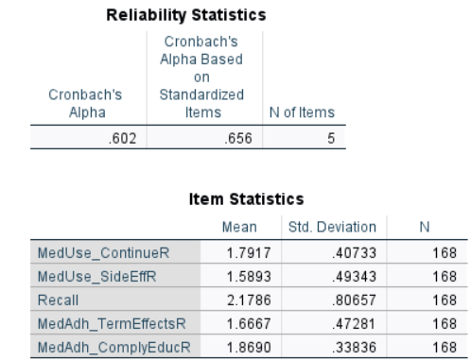

- We note also from the table that deleting the Recall variable would render the effectiveness alpha value to 0.664 (table x).

Table x
  - 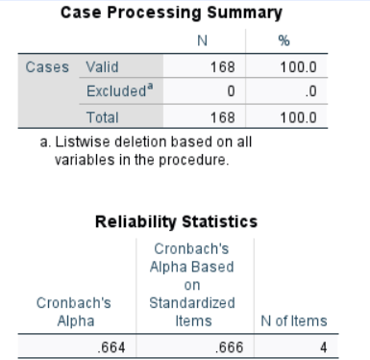

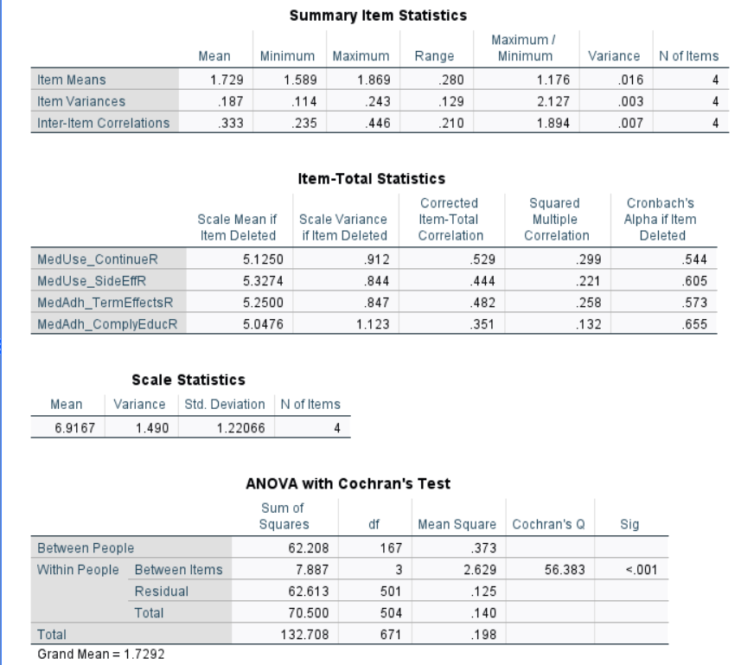
- We observe from the ITEM-TOTAL STATS table that each of the retained variables have corrected item total correlation values greater than 0.30 which is recommended.
- We observe that the exclusion of the MedAdh_ComplyEducR variable would soar the reliability value to 0.665, we will move forward with the analysis using these remaining four variables to analyze the compliance of the male respondents to the use of medication and not remove this variable.
Reporting
Overall, the full scale housed xxxx sub-measures, but because some od not lend much weight to the model, they were removed. The data was administered to 168 males. The Cronbach’s alpha coeffificient for the final scale was 0.602 which consisted of five contributing variables: MedUse_ContinueR, MedUse_SideEffR, Recall, MedAdh_TermEffectsR and MedAdh_CompluEducR indicating a moderate level of internal consistency.

- Correlations to ascertain whether there is a relationship between variables
Concepts of Normal Distribution
Test of Normality: MedUse variables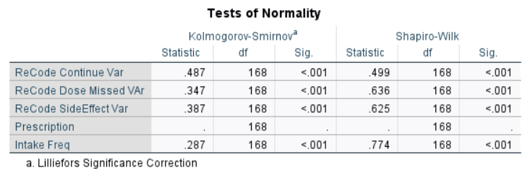
Test of Normality: MedAdj Variables
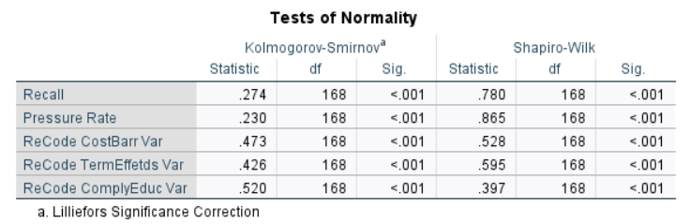
1. For both measures, we see that normality is not satisfied. The Kolmogorov-Smirnov tests in both cases shows that the p-values are <0.05. Will have to resort to some non-parametric test to further analyze a relationship between demographics and medical socioeconomics and to provide further inference.

Test of Normality: Between all variables Compliance variables

Correlation between demographics and Medication non-compliance Responses
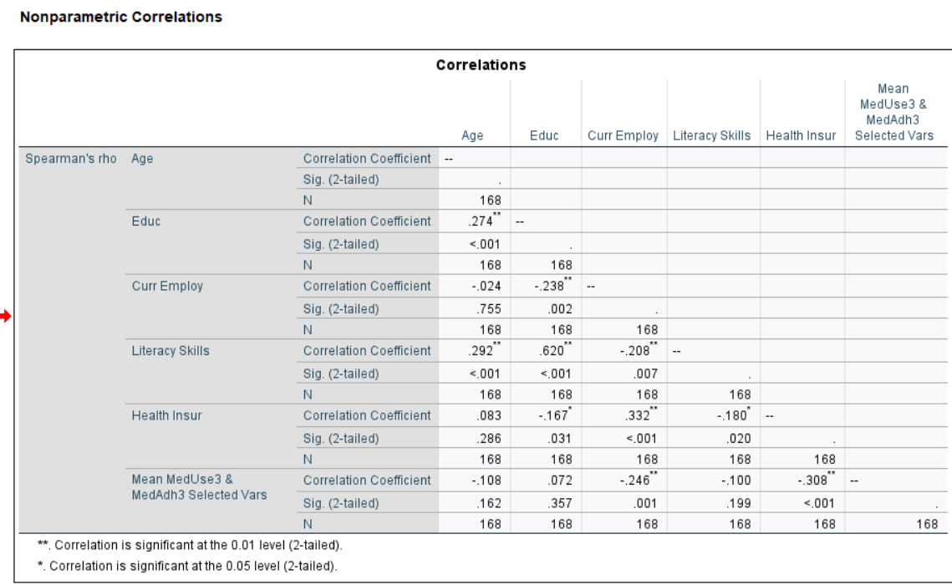
Reporting
- NB: 0.088 > 0.05 so result of the Normality test is not statistically significant and cannot be generalized to entire population;

Logistic Regression Analysis
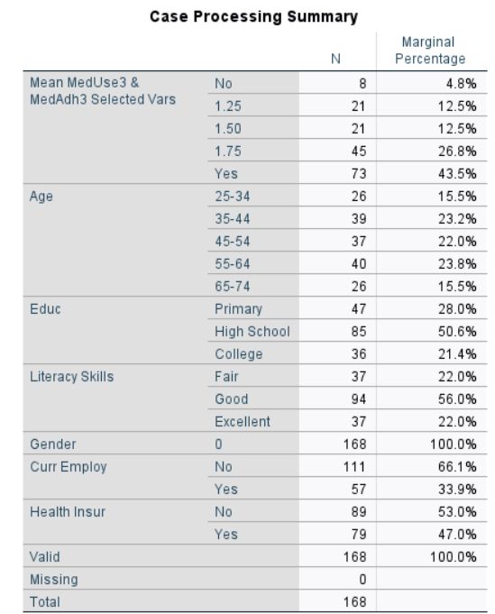

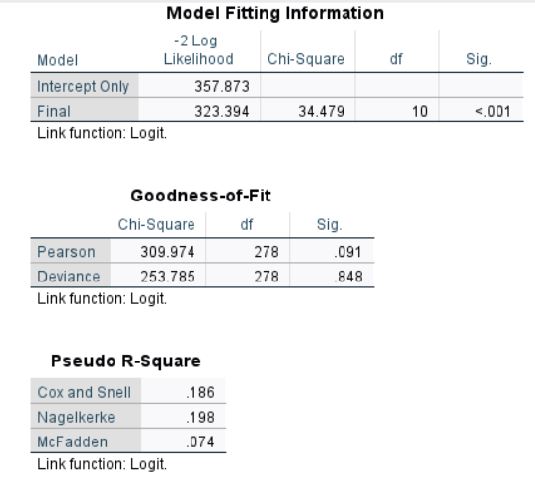

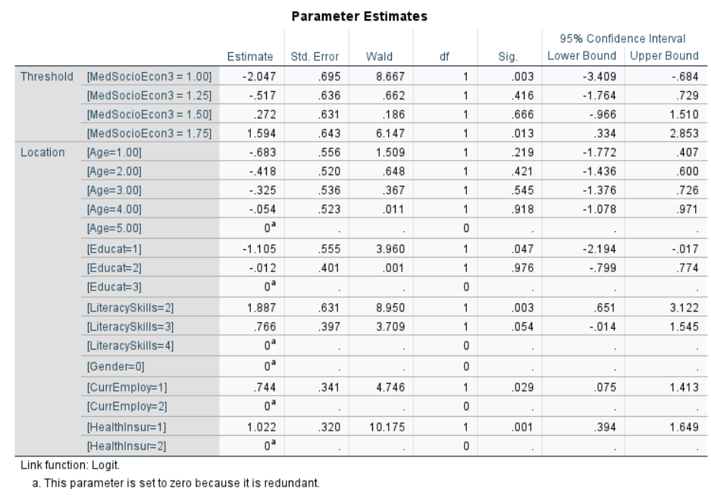

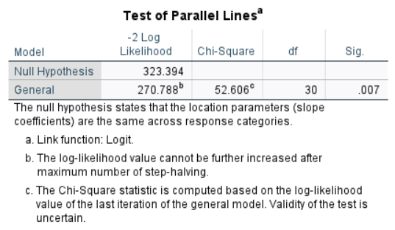
Reporting
- From Model Fitting Information, we note that the p-value<=0.001 is less than 0.05: there is significant improvement in fit when compared to the null model (case of no predictors). Hence the model is showing a good fit.
- The difference between Intercept Only Model and the Final Model should be and in this case is significant;
- Good of Fit table: p-value=.091 > 0.05 – indicating a low fit. This indicates how well the observed data fits the assumed model. The insignificant value of .091 means that there are significant differences in the observed data and the assumed model.
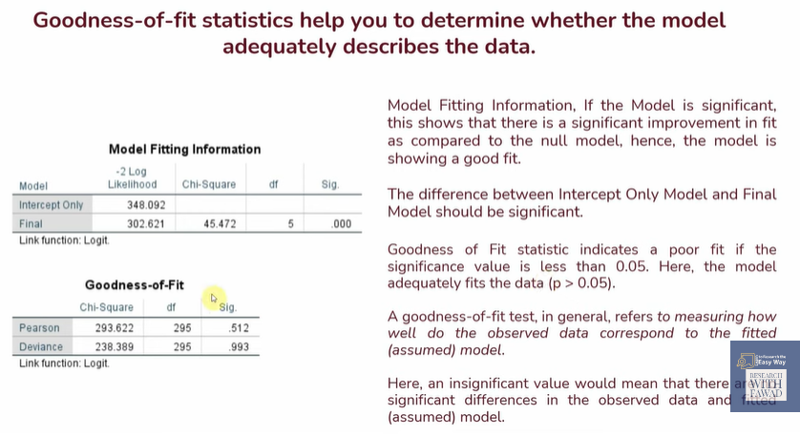
- Pseudo R-Square: Not technically explaining the variation, but the values can be used as approximate variations in the criterion variable;
- We are using the McFadden score of 0.084: there has been a 8% improvement in the prediction of the outcome based on inputted predictors in comparison if no predictors were included;
- Parameter Estimates Table:
- The Estimate shows the probability of a case falling above a given category on the dependent variable
- Positive sign is associated with an increase likelihood of a case falling into a higher category in the dependent variable while a negative sign indicates the opposite.
- From general observation, we note that for the Age variable, the estimates are negative meaning that xxxxxxxxx. The LiteracySkills variables are positive, signifying that xxxxxx. Also for Threshold variable, we have both positive and negative estimates.

- Odds Ratio Analysis:
Insert Excel table with Odd Ratio cals and Explain

- Test of Parallel Lines Table:
a. Assumption of Ordinal Log Regress: Odds of falling into a higher (vs lower) category on DV ae the same across the categories: effect of predictors are the same across the levels of the dependent variable;
b. P-value has to be insignificant for the test of parallel lines to be fulfilled. But here, our obtained p-value=.005 is less than 0.05 so we need to proceed with another test (eg, multinomial regression).
c. We conclude here, that the probability of falling into a higher category varies across the category of dependent variable for the independent variables.

Multinomial Logistic Regression

Inferential Statistics
CHI-SQUARE
AGE
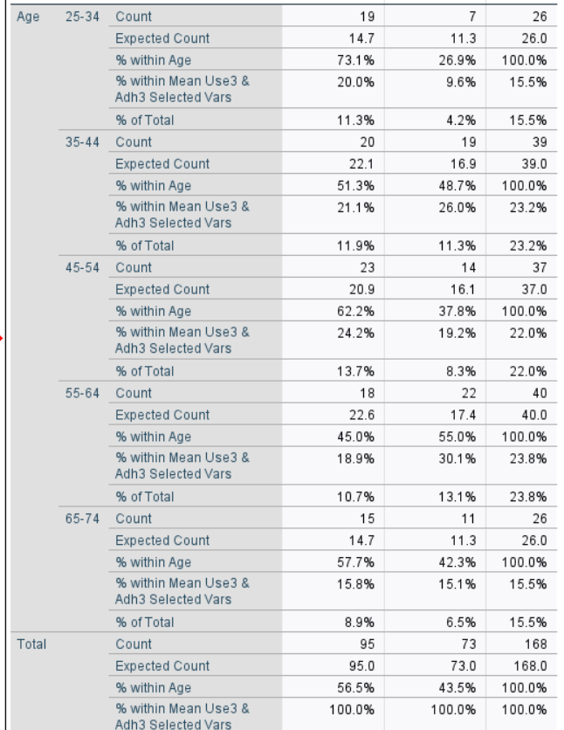

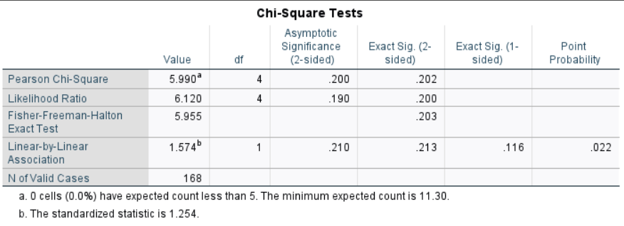

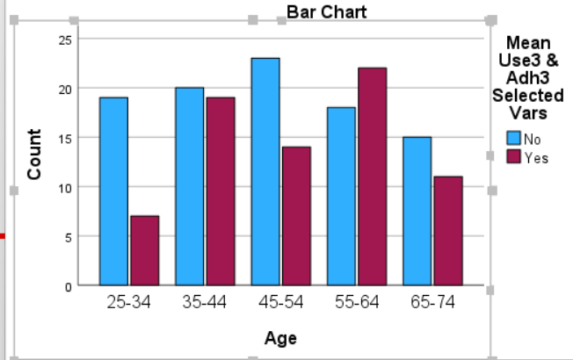

Reporting
The Problem:
To identify the association between males of difference age categories and their compliance to hypertension medication
Chi-square statistics were used to examine association between age groups of males and responses to conformance to hypertensive medication. There is an insignificant association at the 5% significance level between the grouped ages of men and compliance to hypertensive medication (ꭓ²= 5.990, df=4, p=0.202). Test is valid: no expected counts less than 5.

EDUC
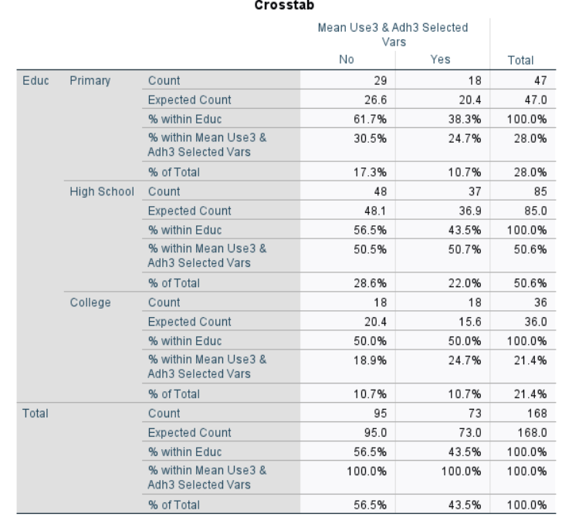

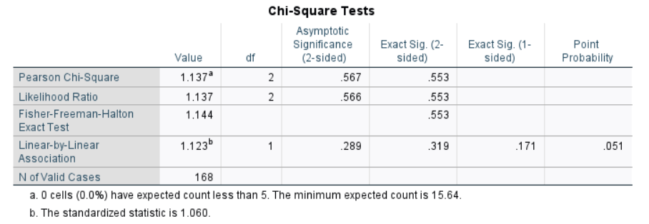

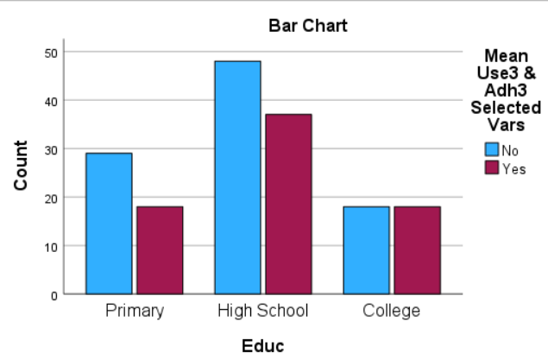

Reporting
The Problem:
To identify the association between males of difference educational levels and their compliance to hypertension medication
Chi-square statistics were used to examine association between age groups of males and responses to conformance to hypertensive medication. There is an insignificant association at the 5% significance level between the grouped ages of men and compliance to hypertensive medication (ꭓ²= 1.137, df=2, p=0.553). Test is valid: no expected counts less than 5.

CURREMPLOY
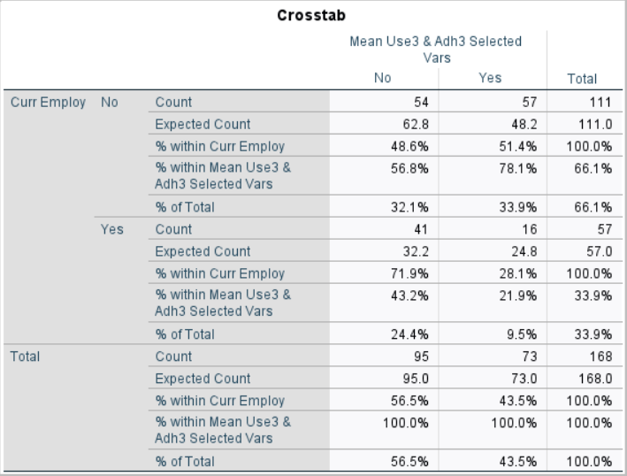

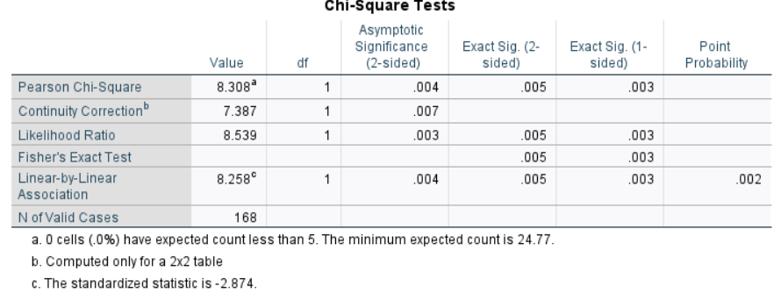

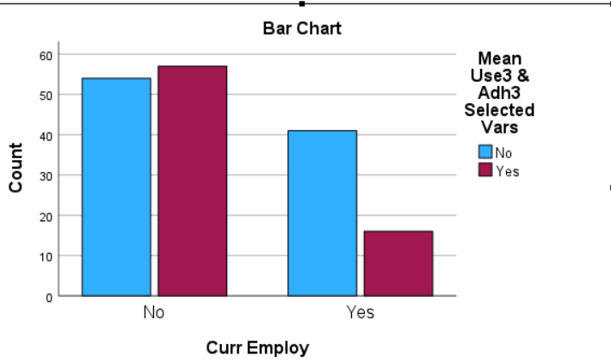
Reporting
The Problem:
To identify the association between males of difference employment status (yes/no) and their compliance to hypertension medication
Chi-square statistics were used to examine association between age groups of males and responses to conformance to hypertensive medication. There is a significant association at the 5% significance level between the grouped ages of men and compliance to hypertensive medication (ꭓ²= 8.308, df=1, p=0.005). Test is valid: no expected counts less than 5.

LITERACY SKILLS
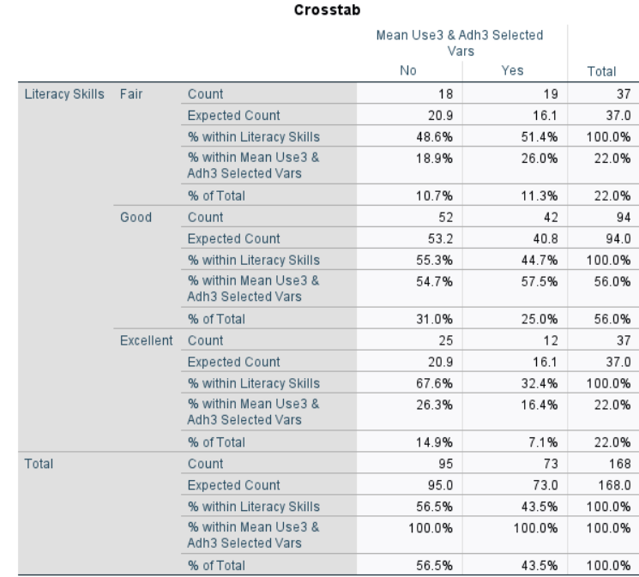

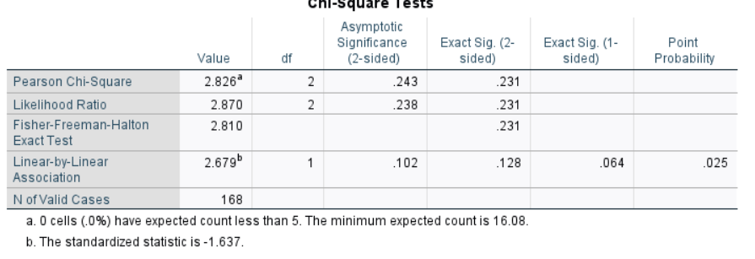

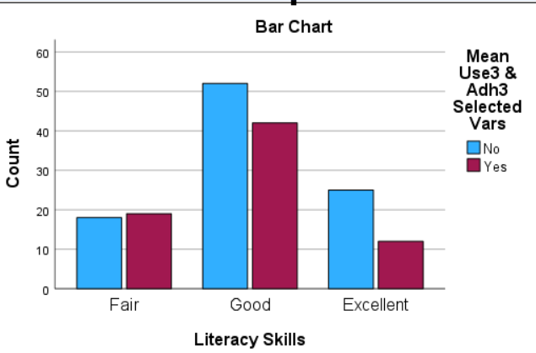
Reporting
The Problem:
To identify the association between males of different literacy skills (poor, fair, good) and their compliance to hypertension medication
Chi-square statistics were used to examine association of different literacy skill levels of males and their responses to conformance to hypertensive medication. There is an insignificant association at the 5% significance level between the males and compliance to hypertensive medication (ꭓ²= 2.826, df=2, p=0.231). Test is valid: no expected counts less than 5.

HEALTH INSURANCE
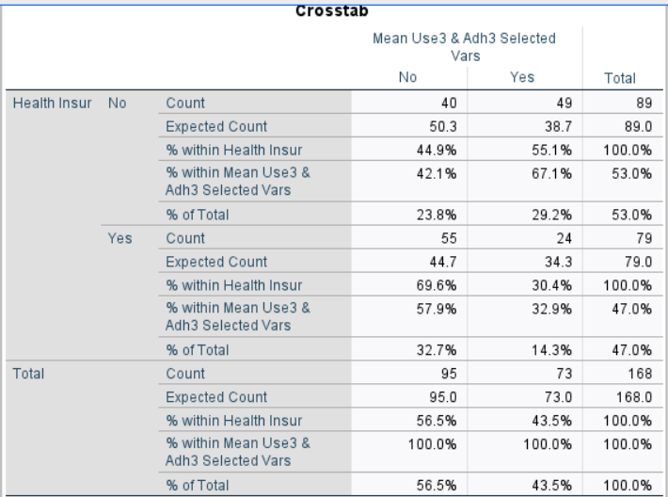

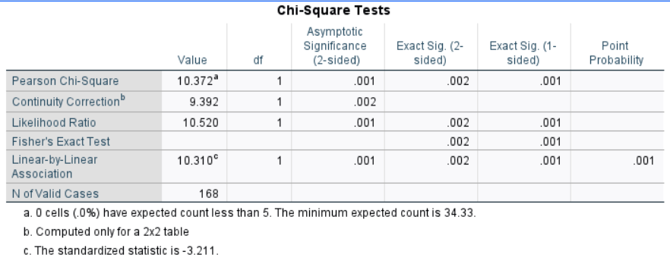
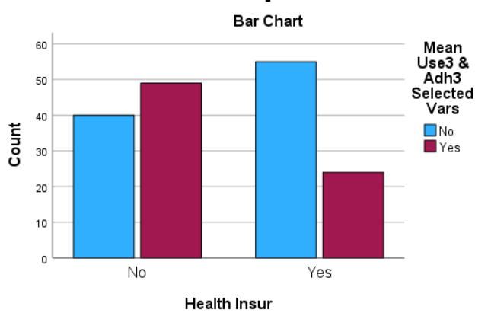
Reporting
The Problem:
To identify the association between males with or without health insurance and their compliance to hypertension medication.
Chi-square statistics were used to examine association between males with and without health insurance and responses to conformance to hypertensive medication. There is a significant association at the 1% significance level between the grouped ages of men and compliance to hypertensive medication (ꭓ²= 10.372, df=1, p=0.002). Test is valid: no expected counts less than 5.

OVERALL CONCLUSION from “Chi-Square Analysis
- Measuring the association of the demographic variables to the non-compliance of xxx the following table concludes:

Variable | Chi-Square | df | P-Value | Conclusion
Age |  |  |  | Not Association
Education |  |  |  | Not Association
Employment Stat |  |  |  | Association
Literacv Skills |  |  |  | Not Association
Have Health Insurance? |  |  |  | Associated

References:

